**Migrant Journeys**

[August 9, 2016](https://www.grownups.co.nz/2016/08/)

[**BOOK REVIEWS**](https://www.grownups.co.nz/interests/book-reviews/), [**GROWNUPS COLUMNISTS**](https://www.grownups.co.nz/life/grownups-columnists/)

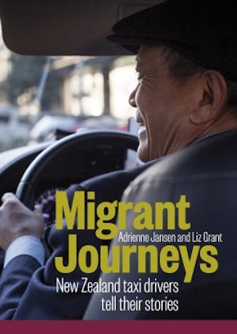**New Zealand taxi drivers share their stories.**

Taxis are often the only place where we have an opportunity to meet migrants from many different countries. So to broaden our knowledge of the refugee and migrant experience the authors, who have taken a few taxis in their time, asked drivers to share their stories: why they came, what it was like to settle here, how they got into the taxi business, and how they see New Zealand and New Zealanders

Out of the fourteen drivers who agreed to be interviewed the majority were men. There were only two women. All have all been in New Zealand for a considerable time.

I found it especially interesting to read their often horrific stories of their previous lives in troubled and war torn countries.  They really appreciate the fact that New Zealand is a safe haven where they can have a peaceful life

But settling in was not easy and there were hurdles to overcome, Often their lack of English and the unwillingness by employers to recognize their foreign qualifications  closed the door to many jobs for which they would have been well qualified.

Although driving a taxi was not what many had hoped to do it turned out to be a good job for most with flexible working hours and sufficient income to provide for their families. They find kiwis are tolerant and they are deeply grateful to those who have gone out of their way to help them to settle in to their new life. Only drunk passengers who often hurl racial abuse at them are a bother.

Sunny Kong, a refugee from Cambodia has driven a taxi here for many years. He arrived here in a very thin shirt and when he got to the Mangere Refugees Resettlement Centre in Auckland he said to his wife:

Oh dear. I think we came to the wrong place. We are going to die in this bloody cold country.”

After a chilly start he battled his way through several redundancies before deciding that taxi driving would allow him to be self-employed. It has turned out to be a good life although he never became rich as he spent a lot of money bringing 30 of his relations here.

Having driven his taxi for 24 years his main focus is now community work. He is very active in the Cambodian community but also belongs to the Karori Golf Club where he organized the Cambodia Cup every year and the money they raised was given to the Mary Potter Hospice

Muneer Oraha, a refugee from Iraq is the managing director of Kiwi Cabs, a very successful taxi company. Many of his drivers also come from Iraq.

“When people here think of Iraq they think of it as a rough place. When I think of Iraq I think of history and civilization,” he says.

He is an Assyrian Christian, born in Nineveh, an ancient city whose history goes back 6000 years. It used to be the capital of the Assyrian Empire. Assyrians invented the wheel, they created laws, and they knew astronomy and had very advanced technologies.

When asked “Why he called his company Kiwi Cabs if so many of the taxi drivers in his company come from Iraq he said“Wherever we live, we want to be part of it. I am living here; I want to serve this place as well as we can”

The overall impression I had of the taxi drivers in this book is that they are good people and solid citizens. They work hard to look after their families, to educate their children and are active in their communities.

It’s a small world. When I shared this book with my son he recognized one of the taxi drivers. He had had a short ride in his cab from the city to the top of Mount Victoria where he house sits. There would not have been enough time for a long conversation so he especially enjoyed reading about this migrant’s experience.

*Migrant Journeys: New Zealand taxi drivers tell their stories  
by Adrienne Jansen and Liz Grant. Publisher: Bridget Williams Books. RRP $39.99*

https://www.grownups.co.nz/interests/book-reviews/migrant-journeys/